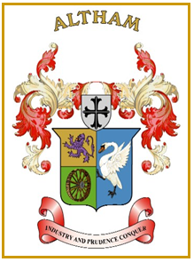
Altham Parish Council
Agenda
(9th Meeting of the Municipal Year 2021 / 2022)
Altham Parish Council Meeting to be held on:
Tuesday, 19th April 2022, at 7.00 pm,
Council Offices, Media House, Burnley Road, Altham.
(The size of the meeting venue is limited to a maximum capacity of 10 people per meeting on health & safety grounds. Members of the public are advised to inform the Council of their intention to attend to aid with meeting arrangements)

A129: Housekeeping
A130: Apologies for Absence
A131: Declaration of Members Interest
A132: Minutes from the Last Meeting
To submit the minutes of the APC Meeting held on the 8th March 2022 for approval as a correct record. (Attached)
Recommended - That the minutes be received and approved as a correct record.

A133: Matters Arising from the Last Minutes (Not listed on the agenda)

A134: Public Participation

A135: Allotments
  - Plot 1C Cromac Terrace eviction notice
  - Livingstone Road skip review/feedback
  - Vacant plots available
  - APC allotment & lengthsman representative
A136: Chairman’s Action

A137: Parish Councillor Updates

A138: Correspondence

- Clayton Triangle Development
- Whinney Hill Road Condition

A139: Finance

A140: Updates on:
- Road Safety (Spids)
- Repair/replacement device
- Spid policy & procedure and questionnaire
- Moorfield Industrial Estate
- Parish Lengthsman
- Crime Figures

A141: Clerks Report

A142: Planning Applications/Consultee Information
Proposed 5G Telecommunications Installation for H3G UK
16.0m Phase 8 monopole c/w wraparound cabinet at base and associated ancillary works
Altham Lane, Altham Business Park, BB5 5US

A143: Event(s)- Update

- Lancashire Platinum Jubilee Event (Bank Holiday-Friday 3rd June)

A144: Any Other Late Business

Date of Next Meeting

The date of the next APC meeting requires confirmation:
- Monday 30th May at 7.00pm (Inc AGM)

