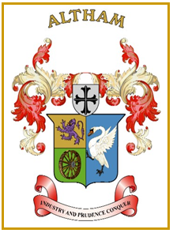
Altham Parish Council
Agenda
(8th Meeting of the Municipal Year 2023 / 2024)
Altham Parish Council Meeting to be held on:
Monday, 17th April 2023, 7.00 pm, at the
Council Offices, Media House, Burnley Road, Altham.

A0106: Housekeeping
A0107: Apologies for Absence
A0108: Declaration of Members Interest
A0109: Minutes from the Last Meeting
To submit the minutes of the APC Meeting held on the 7th March 2023 for approval as a correct record. (Attached)
Recommended - That the minutes be received and approved as a correct record.

A0110: Matters Arising from the Last Minutes (Not listed on the agenda)

A0111: Chairman’s Action
- Elections

A0112: Public Participation

A0113: Parish Councillor Updates

A0114: Correspondence

A0115: Finance
- Payments made and received since last meeting

A0116: Updates on:
- Road Safety (Spids)- Repair(s)
- Moorfield Industrial Estate
- Crime Figures
- Allotments
- Grass Cutting Verges

A0117: Clerk’s Report

A0118: Planning Application

A0119: Events- Updates

A0120: Any Other Late Business

Date of Next Meeting

Monday, 15th May, 6.45 pm (AGM, followed by a Council meeting):

