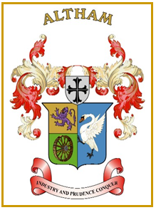
Altham Parish Council
Agenda
(4th Meeting of the Municipal Year 2023 / 2024)
Altham Parish Council Meeting to be held on:
Monday, 25th September 2023, 7.00 pm, at the
Council Offices, Media House, Burnley Road, Altham

A045: Housekeeping
A046: Apologies for Absence
A047: Declaration of Members Interest
A048: Minutes from the Last Meeting
To submit the minutes of the APC Meeting held on the 31st July 2023 for approval as a correct record. (Attached)
Recommended - That the minutes be received and approved as a correct record.

A049: Matters Arising from the Last Minutes (Not listed on the agenda)

A050: Chairman’s Action

A051: Public Participation

A052: Correspondence

A053: Finance
- Payments made and received since last meeting

A054: Updates on:
- Road Safety (Spids)- Repair(s)
- Moorfield Industrial Estate
- Crime Figures
- Allotments
- Grass Cutting Verges

A055: Clerk’s Report

A056: Planning Application

A057: Events- Updates

A058: Any Other Late Business

Date of Next Meeting
To be decided at the meeting

