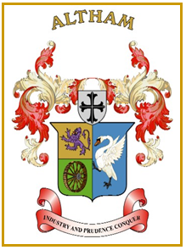
Altham Parish Council
Agenda
(6th Meeting of the Municipal Year 2023 / 2024)
Altham Parish Council Meeting to be held on:
Monday, 06th November 2023, 7.00 pm, at the
Council Offices, Media House, Burnley Road, Altham

A060: Housekeeping
A061: Apologies for Absence
A062: Declaration of Members Interest
A063: Minutes from the Last Meeting
To submit the minutes of the APC Meeting held on the 25th September 2023 for approval as a correct record. (Attached)
Recommended - That the minutes be received and approved as a correct record.

A064: Matters Arising from the Last Minutes (Not listed on the agenda)

A065: Chairman’s Action

A066: Public Participation

A067: Correspondence

A068: Finance
- Payments made and received since last meeting

A069: Updates on:
- Road Safety (Spids)- Repair(s)
- Moorfield Industrial Estate
- Crime Figures
- Allotments
- Grass Cutting Verges

A070: Clerk’s Report

A071: Planning Application

A072: Events Updates

A073: Any Other Late Business

AO74: Date of Next Meeting
To be decided at the meeting

