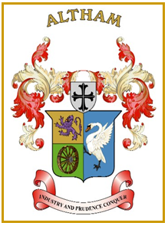
Altham Parish Council
Agenda
(7th Meeting of the Municipal Year 2023 / 2024)
Altham Parish Council Meeting to be held on:
Monday, 18th December 2023, 7.00 pm, at the
Council Offices, Media House, Burnley Road, Altham

A075: Housekeeping
A076: Apologies for Absence
A077: Declaration of Members Interest
A078: Minutes from the Last Meeting
To submit the minutes of the APC Meeting held on the 6th November 2023 for approval as a correct record. (Attached)
Recommended - That the minutes be received and approved as a correct record.

A079: Matters Arising from the Last Minutes (Not listed on the agenda)

A080: Chairman’s Action

A081: Public Participation

A082: Correspondence

A083: Finance
- Payments made and received since last meeting

A084: Updates on:
- Road Safety (Spids)- Repair(s)
- Moorfield Industrial Estate
- Crime Figures
- Allotments
- Grass Cutting Verges

A085: Clerk’s Report

A086: Planning Applications
- Altham St James C Of E Primary School, single storey extension

A087: Events Updates

A088: Any Other Late Business

AO89: Date of Next Meeting
To be decided at the meeting

