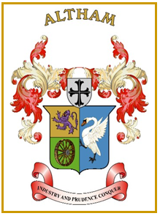
Altham Parish Council
Agenda
(8th Meeting of the Municipal Year 2023 / 2024)
Altham Parish Council Meeting to be held on:
Monday, 29th January 2024, 7.00 pm, at the
Council Offices, Media House, Burnley Road, Altham

A090: Housekeeping
A091: Apologies for Absence
A092: Declaration of Members Interest
A093: Minutes from the Last Meeting
To submit the minutes of the APC Meeting held on the 18th December 2023 for approval as a correct record. (Attached)
Recommended - That the minutes be received and approved as a correct record.

A094: Matters Arising from the Last Minutes (Not listed on the agenda)

A095: Chairman’s Action

A096: Public Participation

A097: Correspondence

A098: Finance
- Payments made and received since last meeting
- APC Budget and Precept

A099: Updates on:
- Road Safety (Spids)- Repair(s)
- Moorfield Industrial Estate
- Crime Figures
- Allotments
- Grass Cutting Verges

A0100: Clerk’s Report

A0101: Planning Applications
- 11/23/0080: Full: Demolition of existing garage and the erection of 6 No apartments with associated parking, Whalley Rd, Accrington

A0102: Events Updates

A0103: Any Other Late Business

AO104: Date of Next Meeting
To be decided at the meeting

