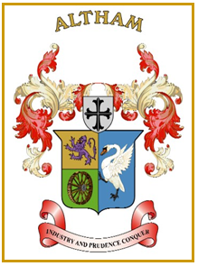
Altham Parish Council
Agenda
(10th Meeting of the Municipal Year 2023 / 2024)
Altham Parish Council Meeting to be held on:
Monday, 22nd April 2024, 7.00 pm, at the
Council Offices, Media House, Burnley Road, Altham

A120: Housekeeping
A121: Apologies for Absence
A122: Declaration of Members Interest
A123: Minutes from the Last Meeting and the Extraordinary Meeting
To submit the minutes of the APC Meeting held on the 11th March 2024 for approval as a correct record.
To submit the minutes of the APC Extraordinary meeting held on 8 April 2024 for approval as a correct record.
Recommended - That the minutes be received and approved as a correct record.

A124: Matters Arising from the Last Minutes and Extraordinary Minutes (Not listed on the agenda)

A125: Chairman’s Action

A126 Public Participation

A127: Correspondence

A128: Finance
- Payments made and received since last meeting

A129: Updates on:
- Road Safety (Spids)- Repair(s)
- Moorfield Industrial Estate
- Crime Figures
- Allotments
- Grass Cutting Verges
- Suez (Landfill) Committee
- Hyndburn Council Local Plan
- The Sport Club land adjacent to Accrington Stanley

A130: Clerk’s Report

A131: Planning Applications

A132: Events Updates
- Workers’ Memorial Day
- Christmas 2024

A133: Any Other Late Business

A134: Date of Next Meeting
To be decided at the meeting, along with the AGM date.

